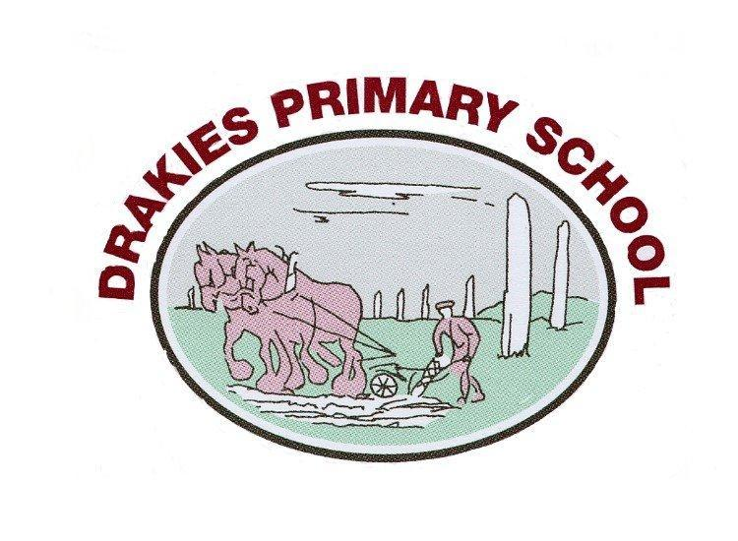


Please ask for: Scott Callander
Telephone No: 01463 236032
E-mail: drakies.primary@highland.gov.uk
Date: Monday 11th November 2019

Dear Parents,

We have had a very busy start to Term 2 and the children have all settled well back into our routine. This letter should give you a brief overview of the work we will be covering this term.

Phonics/Wrap Around spelling
We arrived back at school and jumped head first into the different sounds for our groups. We will continue to learn a new letter pattern each week which will be reinforced through any opportunity that we can find within class. Some pupils will have homework spelling words and others may have a phonics worksheet for practice. To help with blending sounds to make words can you send in any clean milk bottle tops, please? We will write letters on them so that the pupils can “bump” them into each other to blend sounds into words. Make some at home too!


Reading
We have started our new Reading Scheme – Bug Club. It is a phonics based scheme that gets progressively more challenging as the children become more confident with how sounds work in words. You should have received a letter that details how Bug Club works but please get in touch if you would like more information. We very much encourage reading at home so please take any opportunity you can to share a book between you and your child. As well as the reading book of the week being allocated to your child, there is also a bank of books for them to practice their reading at their level and we hope they will find these fun and interesting too. The children have all been shown the website in class and there are lots of features to explore at home. Please do give us some feedback.

Numeracy
This term sees us learning about simple fractions for our P2’s whilst building on the P3’s previous knowledge and challenging them further. We will explore how to show these in different contexts – using food, shapes and materials and even using children and splitting them into groups.
We will re-cap on 2D shapes, including tiling with all the children and also look into 3D shapes and their properties.
We will be continuing to consolidate and develop place value, subitising and addition and subtraction skills too.

PE Kit
We seem to have a lot of children without gym kits. Please ensure your child brings a PE kit (shorts and t-shirt) for use on Tuesdays and Thursdays. PE kits can be kept at school in case of any extra sessions and can be taken home for washing every couple of weeks.

Interdisciplinary Topic
We are hoping to finish off our ‘Julia and Donaldson and Friends’ topic at the end of this month, continuing to use the books to instil values within the children. We will use these books to create our own wonderful pieces of art to showcase our learning. We recently took our learning outside to collect environmental media (leaves and sticks) to use in our Gruffalo’s Child display.

French
We will continue to learn everyday words and phrases using songs and rhymes. Towards the end of term, we will be celebrating Christmas in French!

RME
This term we will continue finding out about the Christian faith through Bible stories and also exploring the theme ‘Festivals of Light’. We will be looking at the Hindu festival of Diwali, the Jewish festival Hanukkah and through our Infant classes nativity play - the meaning of Christmas.

ICT/Chromebook Capers
This term, we will start to ‘buddy up’ with P6/7 who will be passing on their own Chromebook knowledge to the P2/3’s. It has been very successful in previous years and we hope that our P2’s will feel confident in logging on and off independently soon. Our P3’s will be encouraged to access familiar apps with increasing independence that they can use as part of their learning.

Lost Property
Please ensure any clothes, lunch boxes, water bottles, etc. which your child takes to school are clearly labelled in order to avoid any items going missing. With the colder weather coming in, 25 pairs of gloves, hats, scarves and wellies can be tricky to place to the owner if they are not clearly named.

If you have any concerns or queries please don’t hesitate to come and speak to us or send an email to alison.maclean3@highland.gov.uk (Monday-Tuesday) or jacqui.barclay@highland.gov.uk (Wednesday, Thursday, Friday)

Thank you for your continued support,

A MacLean and J Barclay
(P2/3 teachers)
Dates for your diary:
- Thursday 21st and Friday 22nd November- In-service days (children off school)
- Wednesday 11th December – P1-3 Nativity
- Thursday 12th December – school closed for Polling day
- Friday 20th December – School closed for the holidays

